**Quiz: Boolean logic**

Link to the quiz: [Quiz: Boolean logic | Watch and Code](https://watchandcode.com/courses/350615/lectures/23008880)

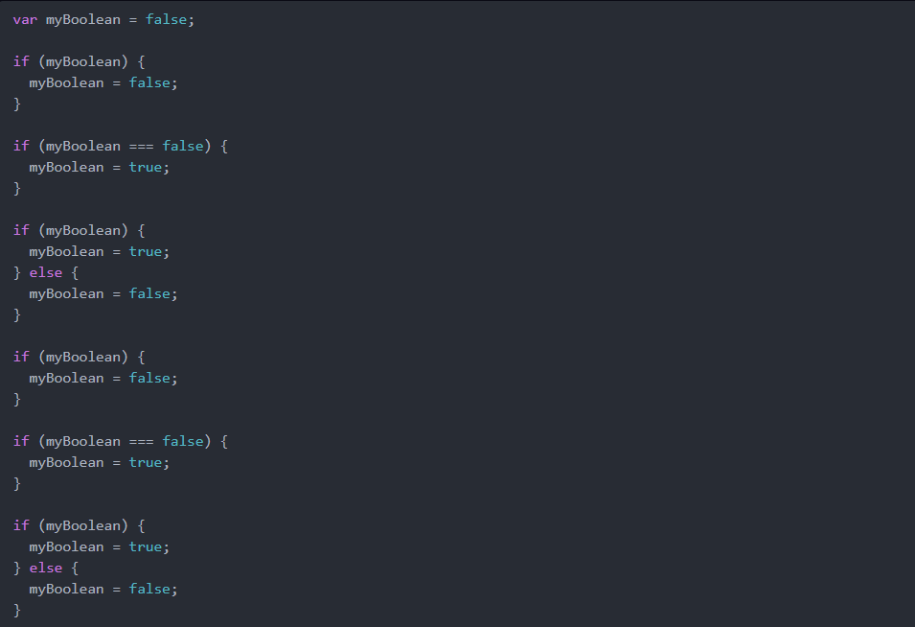

In the above code, how many times will the value of myBoolean change from true to false?

1. One time
   1. True 100%
   2. The 4th conditional statement is the only if statement where the value of myBoolean changed from true to false.
2. Two times
   1. False 100%
   2. The 4th conditional statement is the only if statement where the value of myBoolean changed from true to false.
3. Three times
   1. False 100%
   2. The 4th conditional statement is the only if statement where the value of myBoolean changed from true to false.
4. Zero times
   1. False 100%
   2. The 4th conditional statement is the only if statement where the value of myBoolean changed from true to false.